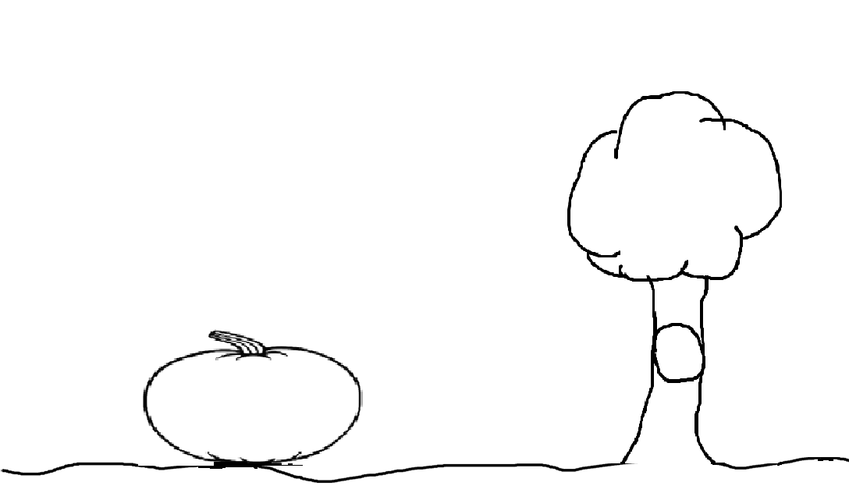

Name___________________________________________________

